Konnekt Captioning Videophone

Type of device: Landline - TTY (Text Telephone)
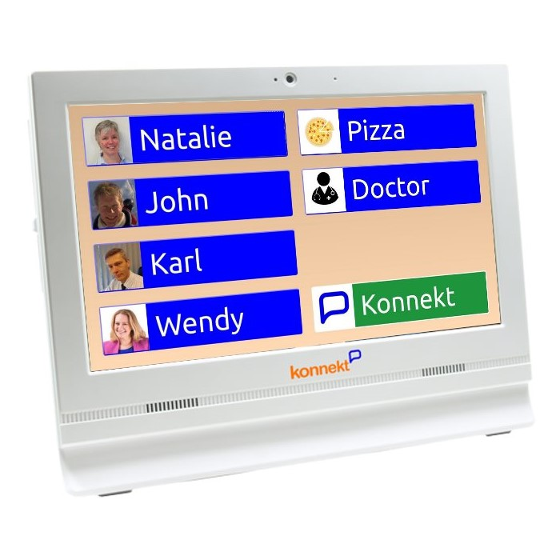
Konnekt Captioning Videophone requires an internet connection to work, it does not work over a standard phone line like the other TTY devices listed on this website
Konnekt Captioning Videophone is an alternative to replace the former Captel, which consisted of a phone with a screen for live captions.

Actual Display Size : 15 inches
Button Type : Touchscreen
Year of Release : 2020
Average Price : Please contact Konnekt for rent or purchase prices

Accessibility Features:

Cognitive
- Screen Timeout Disabled
- Simple Instructions
Simplify Display

Hearing Impairment and Deaf
- Allows for sign language communication
- Bluetooth or Wi-Fi
- Closed Captioning
- Front Facing Camera
- Hearing Aid Telecoil Coupling
- Video Communications - Two-way
Visual Alerts - Incoming Calls

Vision
- High Contrast Mode
Text Size Adjustable

Speech
Allows for sign language communication

Physical
- Automatic Answer
- Flat Back for Table Top Operation
- Speaker-phone option
Switch control option

How and where to get it from?
You can rent or buy this phone from Konnekt

More information is available on:
Konnekt Captioning Videphone Webpage
Konnekt Captioning Videphone Product Flyer

